Coursework A

# Datasets repositories

## Data Market: <https://datamarket.com/>

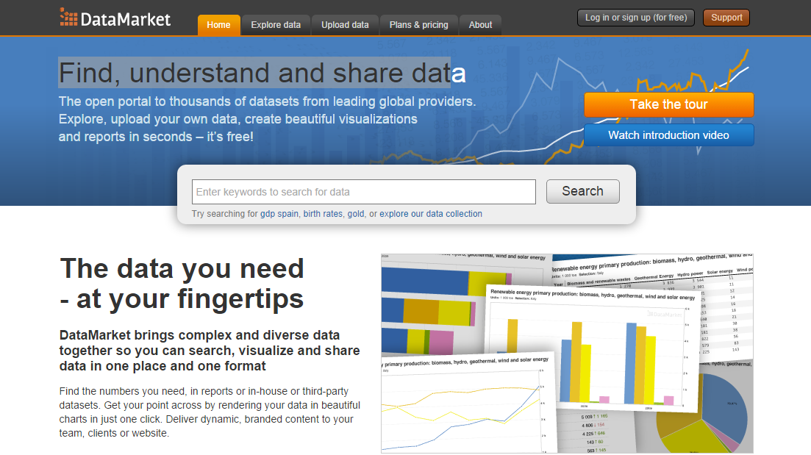

This website contained very large amount of dataset especially time series data. The source of data come from various major organizations such as The Economist Intelligence Unit, United nation and World Bank. The majority of data provided in this site are from industry sectors and statistic data from countries around the globe. They provide tools that easily find the data you want from their website. Moreover, this site display data with an interactive visual data. You can chose any fields you want, customize a perspective of visual data and export them into a PDF file or share your topic on social media website. For a researcher who need raw data, you can directly download them from website or receive live data feed using their API. You can also gain a direct access to the repository using CVS (Concurrent version system).

## Open Source Sports: <http://www.opensourcesports.com/>

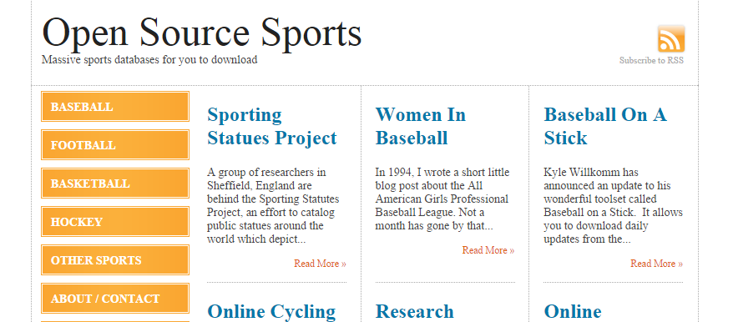

Open Source Sports, obviously as the name say they are specialize in sport. Actually, their data set cover only Baseball, Basketball and Hockey. Their Hockey and Baseball data set are available to download since 1995 till 2013. They provide an annual statistic data of teams and players. You can download data set as Microsoft Excel, Microsoft Access or an actual data base SQL file. There are no visual data on their website. Just simple click and download.

## Berkeley Earth: <http://berkeleyearth.org/>

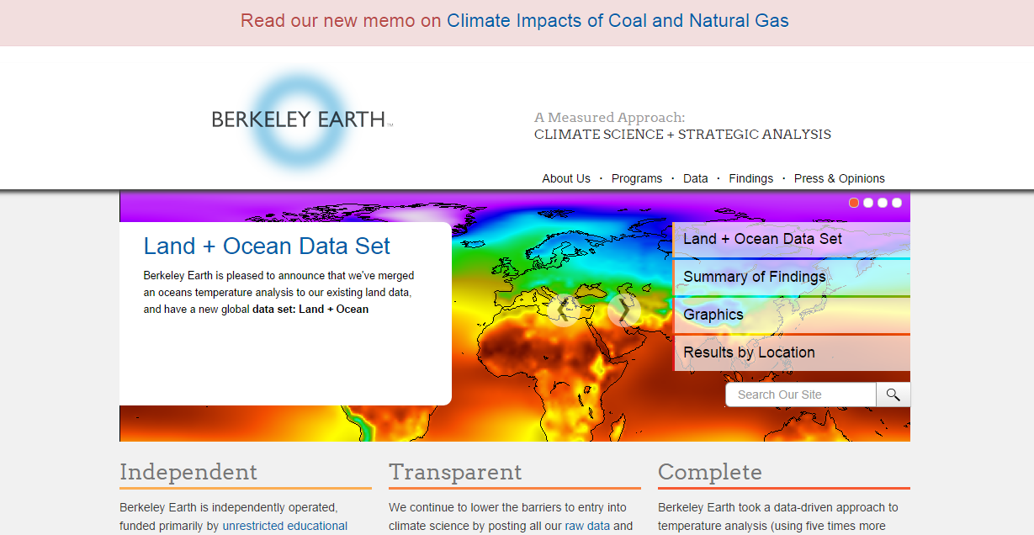

Berkeley Earth is nonprofit organization who gather earth surface temperature both land and ocean in order to analyses the data and deliver an information that will help to reduce global temperature rising currently focus on developing country especially china. The raw temperature data come from all weather station around the world. They analyze the data and produce visual base presentation using tool from google earth. Their data set divided into 3 categories Output data, Source data and immediate data. You can directly download Output data and Source data from their website. An immediate data is stored in their repository. You can connect to their repository and download those data using CVS. Their recent Analysis code also available to download on their website.

Mr. Wanchana Ekakkharanon: MSc Data Science.